**Running the Script**

1. To run the script, go to the tab in IDEA where you have the script saved to your tool bar and click that.
2. 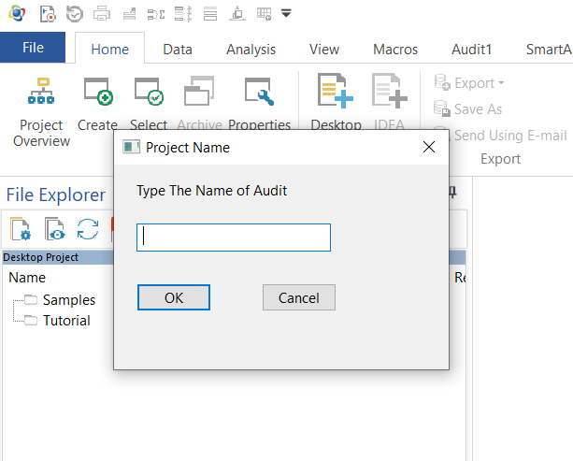You will then be prompted to give a name for the audit. This name will be attached to the final result. If you don’t give a name it will default to “Split Transaction.”
3. Next you will locate the loop and pull.iss file. This will help you bring in P-Card excel files. This should be located at 2020 Activities\A.04.2020 - Continuous Audits\Data Analytics\Active Scripts\Master Scripts in the internal drive.
4. You then will be asked how many P-Card files you want to pull into IDEA. You will then be able to pick the files you want. Navigate to the location of the file you want to pull. For this script you will want to select the Excel files only. An important note to watch for at this step. If you try to pull in an excel file that has the first row empty IDEA will crash. This is a bug with IDEA that we have not resolved yet. If this happens go into the excel file and remove that first row.

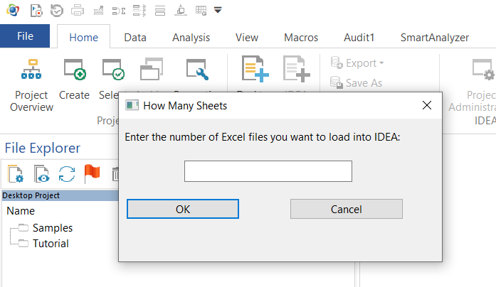

1. Next you will enter a date rang that your audit will filter through. In this dialog box you’ll be prompted how to enter the date. If you enter it incorrectly it will ask you to re-enter 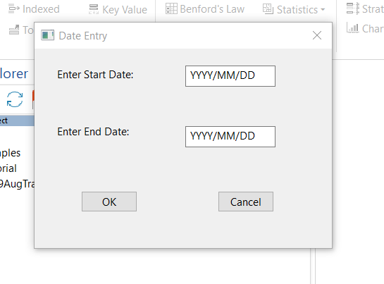the date. You’ll enter a start date and end date. What this will do is filter the new database so you only have results between those dates.
2. At this point the program should run to completion. The database open at the end will be your potential split transactions.